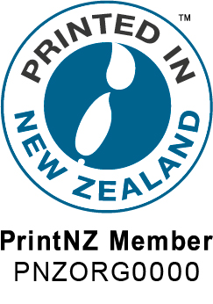

PRINTED IN NEW ZEALAND LOGO
APPLICATION FORM

ORDER NOW AND PAY IN 2022

The Printed In New Zealand logo has been developed to encourage PrintNZ Members and their customers to proudly declare their work is exactly what the logo says – Printed In New Zealand.

Our industry produces world class work and we want to let everyone know exactly where that work was printed, and that it was printed by a member of PrintNZ.

This logo is only available to our members and incurs a one-off set-up cost of $250.00 plus GST per site to have your PrintNZ member number embedded in the logo. A full set of eps, jpg, png and pdf logos will be supplied.

Sign up and let the world know it was Printed In New Zealand.

Company: ______________________________________________________

Name: ______________________________________________________

Email: ______________________________________________________
------------------------------------------------------------------------------------------------------------------
TAX INVOICE GST NO: 10-161-746
Please retain a copy of this registration as it will become a GST invoice once paid

Payment Options Payment for $287.50 will be paid as follows:
- Direct Credit - 06 0501 0035906 02 Ref: Printed In NZ
- Invoice me
- Credit Card – Visa Mastercard

Credit Card:

Expiry Date: __/__ 3 digit security code on back of card

Cardholders Name________________________________________________

Signature_______________________________________________________
Email this form to info@printnz.co.nz

